Accessing the TRE
The Trusted Research envionment (TRE) “er_tre_msc_dcdm_users” was added to my Kings Research portal under the “Trusted Research Environment” tab.

In this tab there are three Virtual Machines (VMs) all of which can be used to access the data.
link

Logged into the TRE using:
- Knumber
- Uni Password
- Domain was left blank
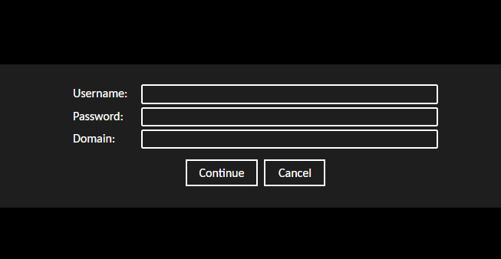

Once logged into the TRE, I used the folder application to find the groups data. The data was already in the projects file location so there was no need to move it.
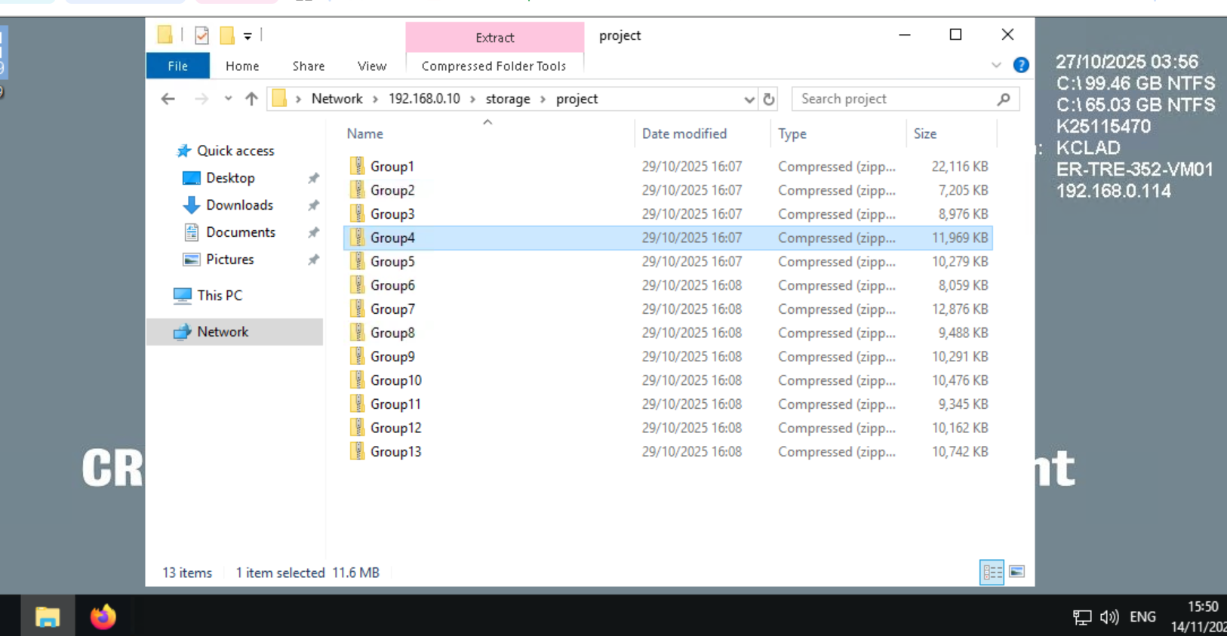

Then clicked on the data egress portal shortcut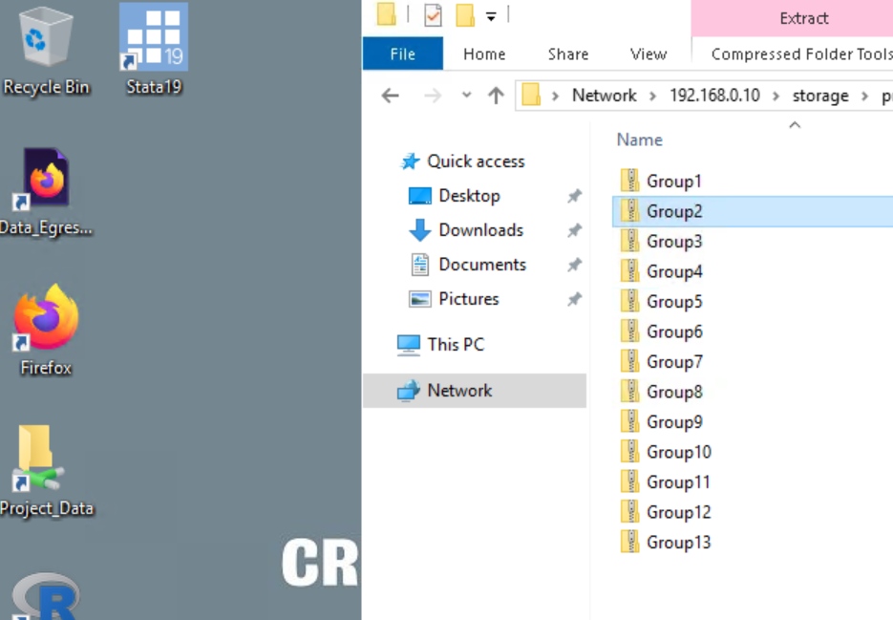

After logging in it takes you to this homepage, where I clicked Egress request.
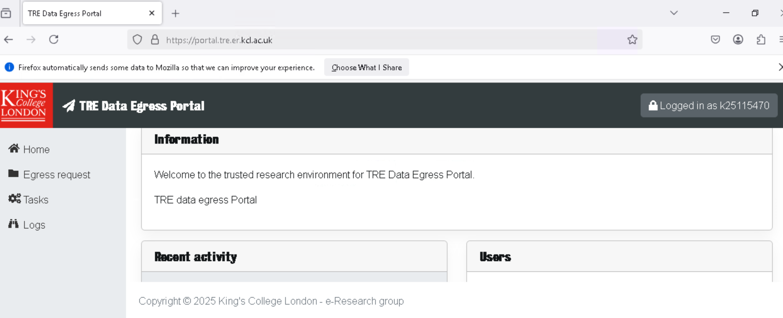

This takes you to the TRE egree portal where you can fill put the different questions in the form.
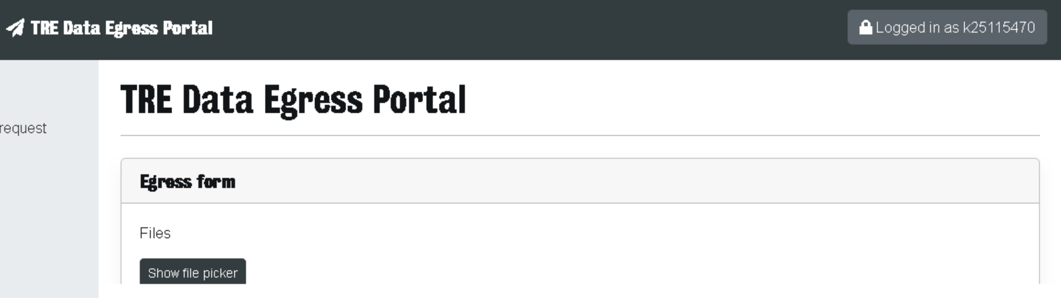

Q1.
Identifying the data that needed egressing. I.e Group4.zip
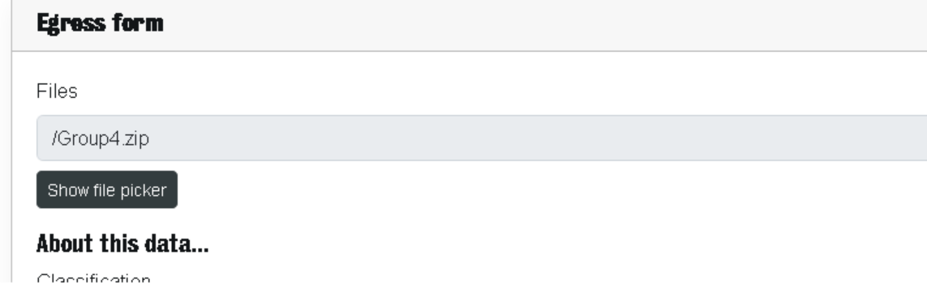
Q2.
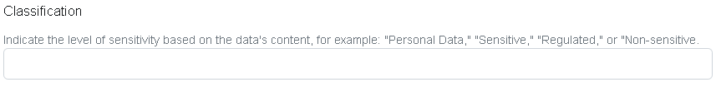
Here I indicated the data as “non-sensitive”, as it does not contain any personal data, it is not being regulated by anyone as it's open to use, and it is not sensitive as it does not contain any human or personal data.

Q3.
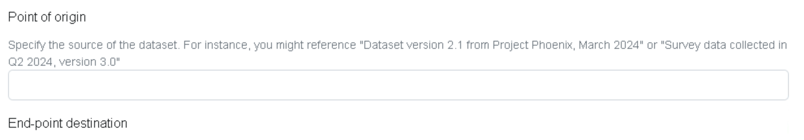
Here, I wrote that the data came from the International Mouse Phenotyping Consortium (IMPC).

Q4.
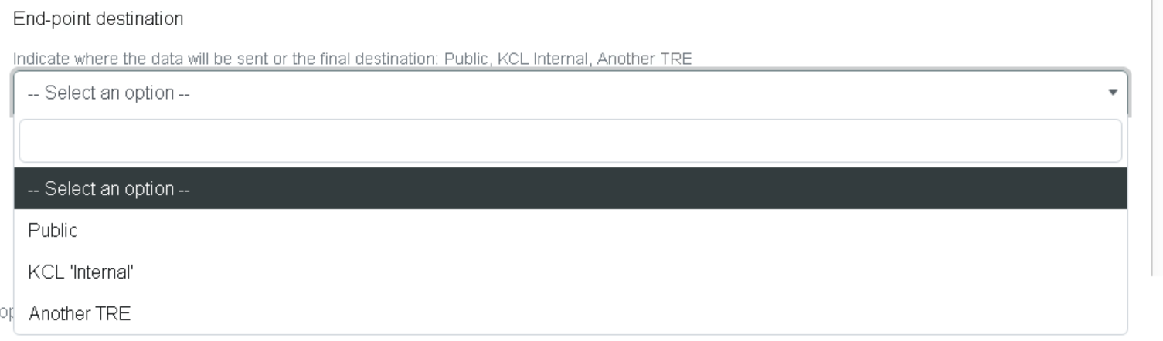
For the end-point I clicked KCL internal

Q5.
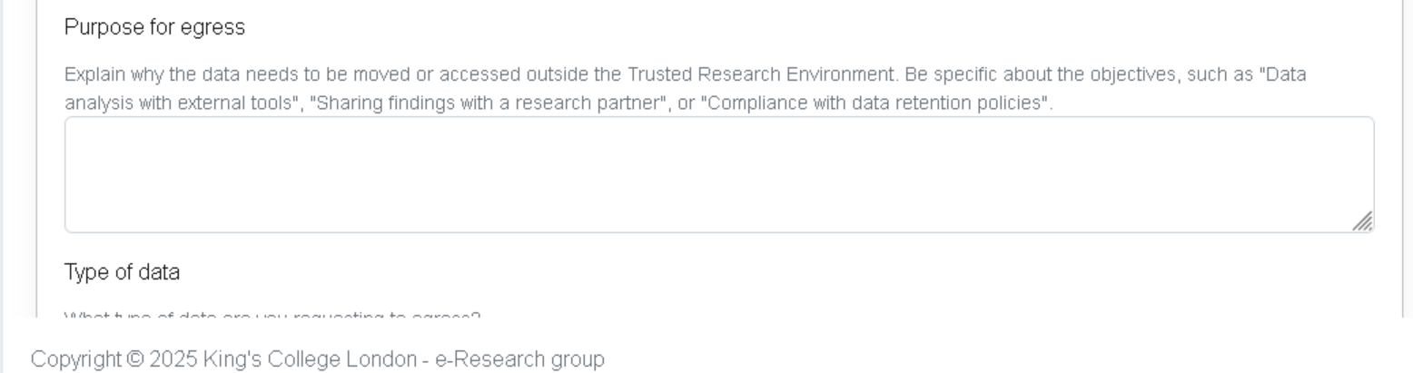
Here I wrote, the purpose of egress was so that we could complete out DCDM 2025 group coursework.

Q6.
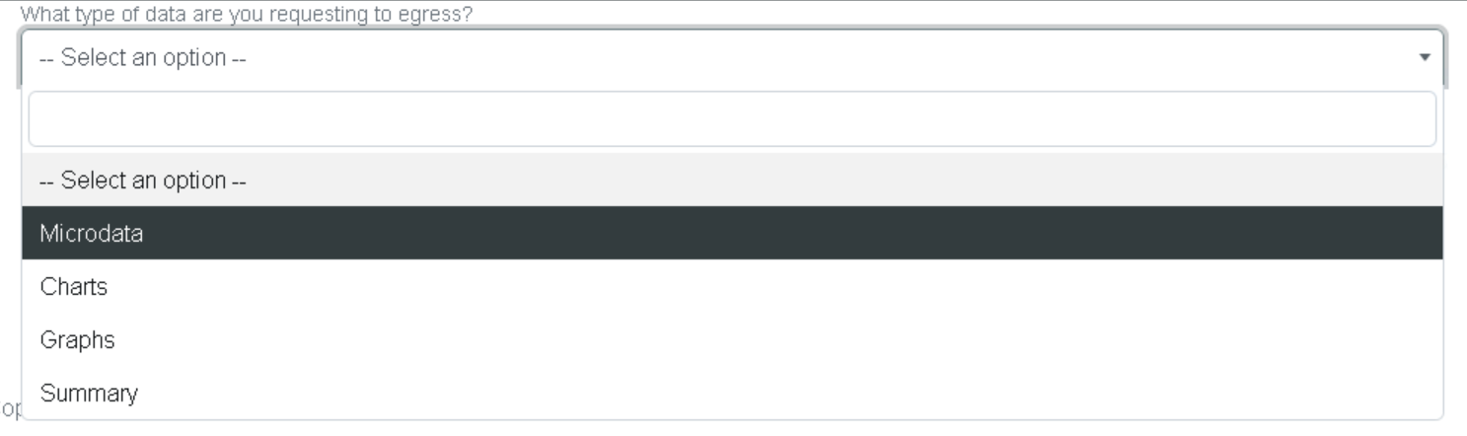
For the type of data I chose, microdata, as the data are raw, uncleaned information.

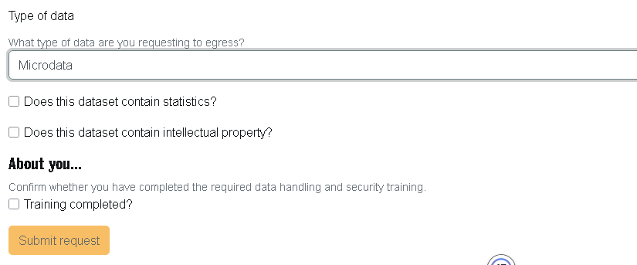
The last 3 tick boxes;

Does the data contain statistics? – Ticked the Box because our data contains P-values
Does the dataset contain intellectual property? – Left unticked, as from what I could find, the IMPC data is made freely available and is not intellectual property.

I left the “training completed” box unticked because I have not completed any training associated with the TRE.

After completing this, I clicked on the “submit request” button.

Our request then appeared in the tasks section of the TRE Data Egress Portal.
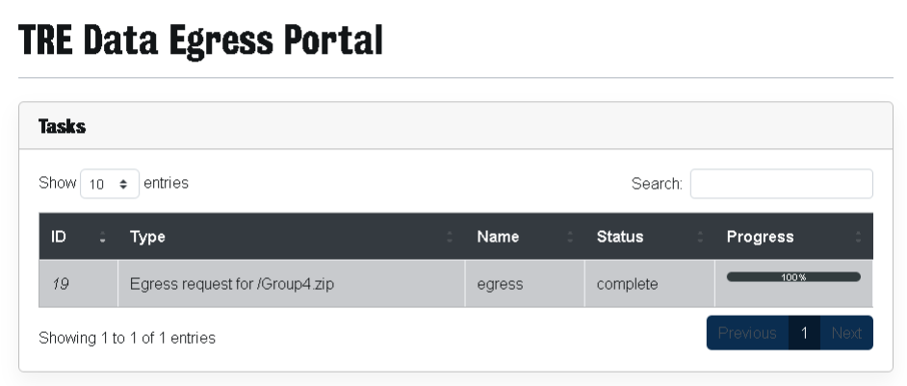

When our data had been egressed, I was emailed by Fursham Hamid with where our data had been egressed to on the HPC.
